2024

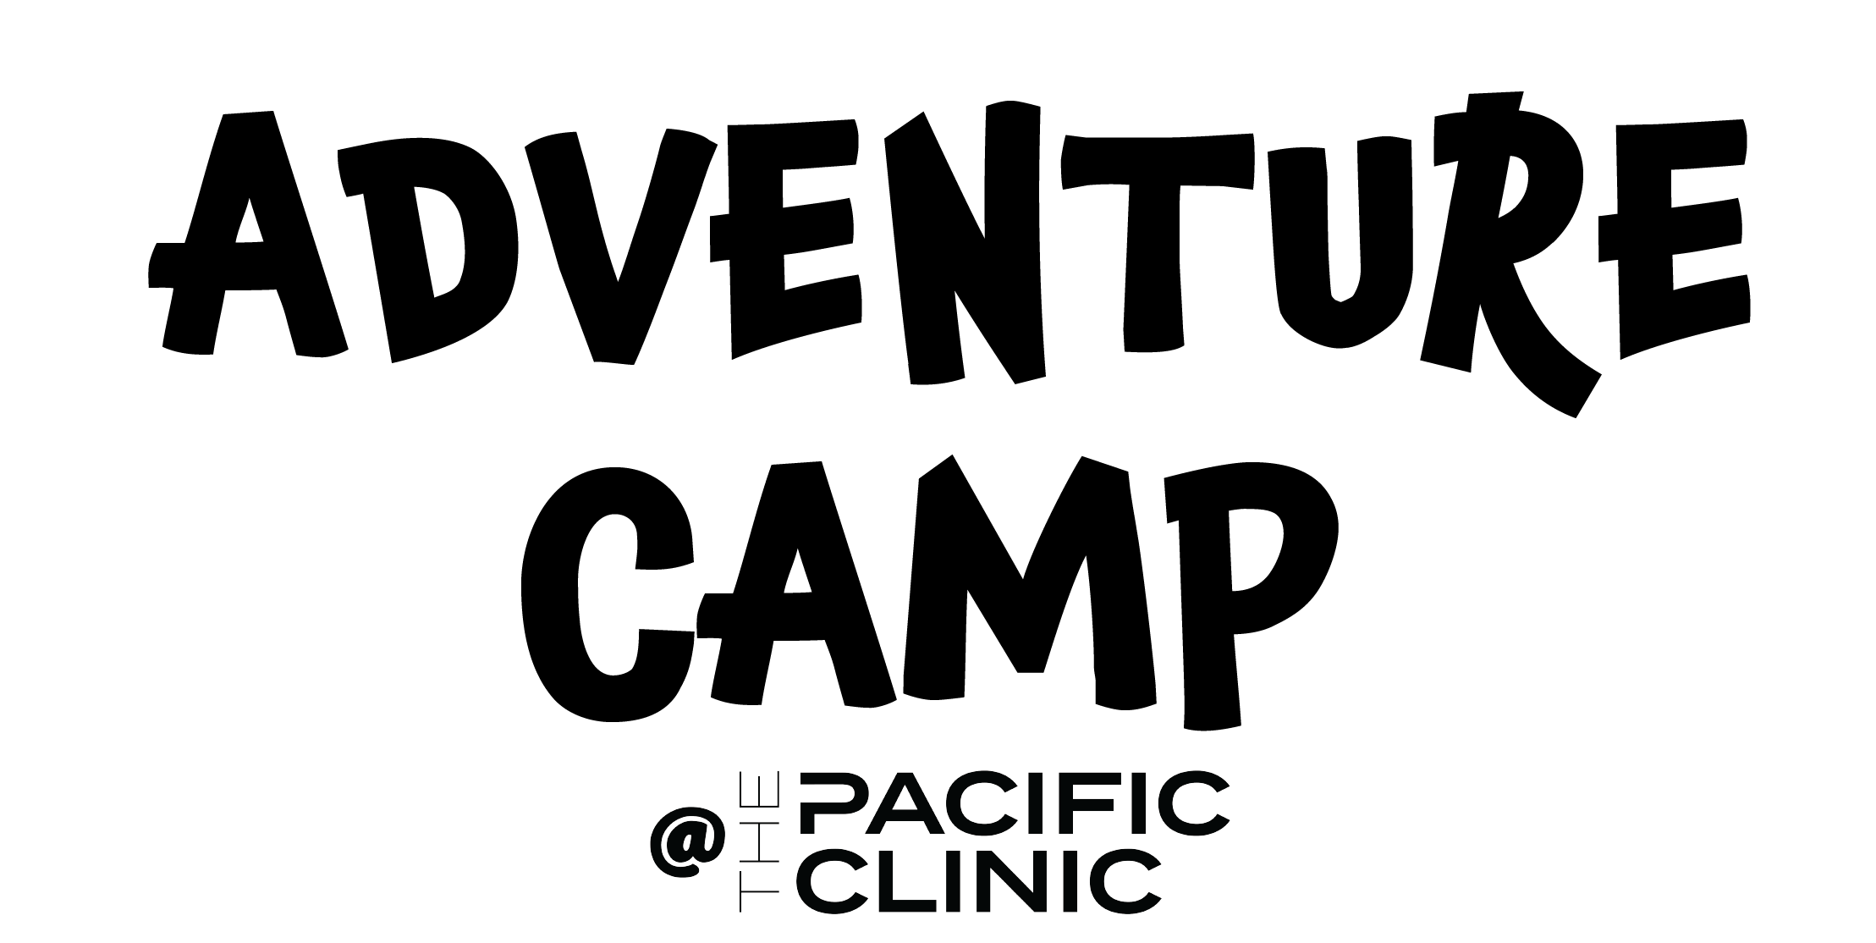
Warning: Children must be able to jump in deep water and swim 20 yards without assistance or touching the wall of the pool to enroll in camp.

Circle one: Member Community
Campers full name:  Date of Birth: | Complete address:  E-Mail address:
Parent #1 name:  - Home phone:  - Work place:  - Work phone:  - Cell phone: | Parent #2 name:  - Home phone :  - Work place :  - Work phone:  - Cell phone:
Physician name:  Physician phone:  Preferred hospital: | Three emergency contacts – name and numbers  NAME NUMBER  1.  2.  3.
Additional persons authorized to pick up your child  (name and phone number)  NAME NUMBER  1.  2.  3. | List specifically any allergies your child has to  - FOOD  - MEDICINE  List all medication your child takes on a regular basis
List any and all physical conditions which limit his/her participation in activities.

Behavior Policy: Adventure Camp is a highly active camp. Not a “daycare” provider. We hold high expectations of behavior in our camp. Children who do not listen or respect the counselors and/or other campers will be given an opportunity to redirect their behavior, if the behavior continues or gets worse the guardians will be contacted and asked to pick up their child. Children who continue to misbehave or display aggression toward staff or other campers will be dismissed and asked to find another camp to participate in for the remainder of our camp's duration. Fighting is an immediate removal from camp for the remainder of the camp's duration.
Parent Initials: _________

Photo Release: I give permission for The Pacific Clinic to use pictures of my child in advertising, brochures, newsletter, social media and website. All photos will be taken by a member of our Marketing Team or the Camp Director.
Parent Initials: _________

Waiver: The Pacific Clinic shall not be held liable for any injury incurred in any camp activities, or any other use of equipment or facilities of the Clinic. The Pacific Clinic shall not be liable for any lost or stolen goods that may have been left or taken from the facility. I hereby waive and release any and all rights for myself, my heirs, executors, and administrators this enrollee may have against Pacific Clinic or its representatives, agents, and successors for any and all injuries the participant may suffer in connection with his/her participation in any The Pacific Clinic camp program.
Parent Initials: _________

Medical Waiver: We understand that in case of emergency and we are unable to be contacted, we give permission to Pacific Clinic to authorize any emergency action necessary to ensure the safety of our child. This does not in any way hold Pacific Clinic financially responsible or otherwise liable for any medical or emergency care given. I permit my child to participate in all activities at Pacific Clinic and to be transported to off-site field trips.
Parent Initials: _________

Refund Policy: I understand that The Pacific Clinic has a no refund and switching of days policy and if my child misses camp on a purchased day I forfeit the funds for that day.
Parent Initials: _________

Snack Purchase Policy: I understand my child will be given two opportunities for snacks in addition to their lunch. I also understand that unless Adventure Camp is attending SplashDown Cove they will not have an opportunity to purchase snacks from the service desk at any point during their day in camp.
Parent Initials: _________

Lunch and Snack Policy: I understand that nut products are not allowed at camp in any capacity. If my child is sent to camp with a snack that contains nut products the staff will confiscate that item and replace it with an item provided by the Camp Director (at no additional cost) and the guardian will be notified upon pick up. If my child’s primary lunch item contains nut products the camp staff will prevent consumption of that item and call the guardians on the waiver sheet to bring in another main lunch item or obtain permission for my child to purchase something from SplashDown Cove during Adventure Camps scheduled time but only if camp is scheduled to attend that day.
Parent Initials: _________

Cell Phones/Personal Communication Devices and Electronics: I understand that cell phones and personal communication devices (smart watches) are for genuine emergencies only. If a camper needs to speak to their guardian they can use the facility phone with permission and assistance from the counselors at a time that is not disruptive to the activity scheduled when permission is requested. I also understand that if my child has a device with them at camp and it is brought out they will be asked to put it away, if it is brought out a second time a camp counselor or the camp director will call to inform the guardian of the removal of the device and it will be placed in a secure location until a guardian picks up the child and staff places the device in the guardians hand with further explanation if needed. Smart watches are permitted to be worn as long as they are not a distraction, should they become a distraction the previously mentioned steps apply. Please note if a child is found to be taking photos during camp the device will be Immediately placed in a secure location, staff will call to inform the guardian and then upon pick up will ask the guardian to delete the photos, this is to respect the privacy and wishes of individuals that do not wish to have their photos taken.
Parent Initials: _________

Illness: The Pacific Clinic (“The PC”) has put in place preventative measures to reduce the spread of COVID-19; however, The Clinic cannot guarantee that you or your child(ren) will not become infected with illness. Further, attending The PC could increase your risk and your child(ren)’s risk of contracting illnesses.
​
If my child or myself has any of the following, I understand I we are not allowed to enter the facility and we agree to abide by these expectations:
- If we have been diagnosed with COVID-19 and have not recovered or am still within the required 5-day quarantine.
- If we had symptoms of COVID-19 within the last 24 hours. Or if we experienced the following: a fever, cough, shortness of breath, sore throat, loss of taste or smell, vomiting or diarrhea or any other symptoms, they will stay home.
- If we had contact with a person who has or is suspected to have COVID-19 within the last 14 days.
- We agree to not enter the facility if we are sick. We will cover my cough or sneeze with a tissue and wash my hands. We will not touch our eyes, nose, or mouth and will practice good hygiene.
- We will abide by social distancing and provide personal space to others
- We agree to wash my hands upon entrance to the Clinic (if mandated) and frequently with soap and water for at least 20 seconds. Or use hand sanitizer.

By signing this agreement, I acknowledge the contagious nature of COVID-19 and other illnesses and voluntarily assume the risk that my child(ren) and I may be exposed to or infected by COVID-19 and other illnesses by attending the Clinic and that such exposure or infection may result in personal injury, illness, permanent disability, and / or death. I understand that the risk of becoming exposed to or infected by COVID-19 at the Clinic may result from the actions, omissions, or negligence of myself and others, including, but not limited to, Clinic employees, volunteers, and program participants and their families.
​​
I understand and agree that this release includes any Claims based on the actions, omissions, or negligence of the Clinic, its owners or employees, agents, and representatives, whether a COVID-19 infection occurs before, during, or after my participation in any Clinic usage, lesson, class, or program.

I HAVE CAREFULLY READ THIS AGREEMENT AND FULLY UNDERSTAND ITS CONTENTS. I AM AWARE THAT THIS IS A RELEASE OF LIABILITY AND A CONTRACT BETWEEN MYSELF AND THE ABOVE LISTED INDIVIDUALS AND GROUPS AND/OR THEIR AGENTS AND CONTRACTORS, AND I SIGN OF MY OWN FREE WILL.

Parent Signature: ___________________________________________ Date: ______________________

